**Dockerfile**

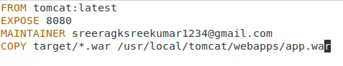

**docker-compose.yml**

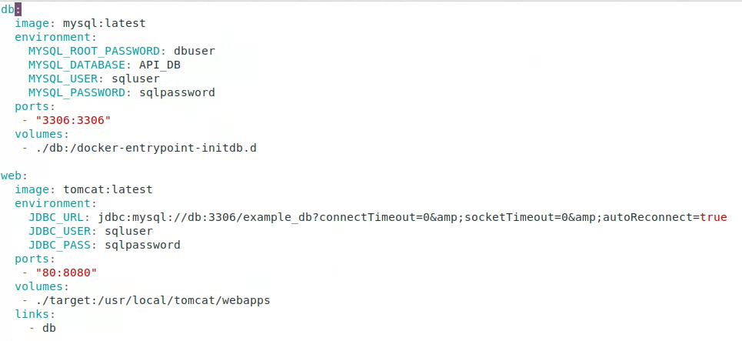

**docker build**

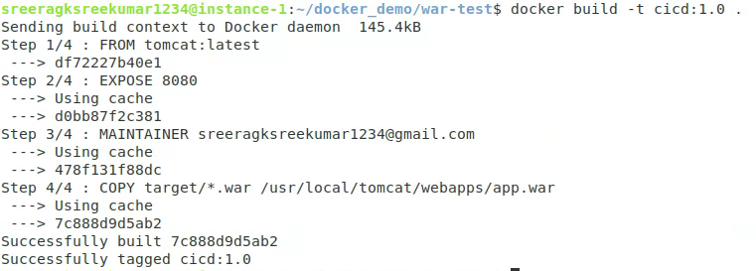

**docker-compose execution**

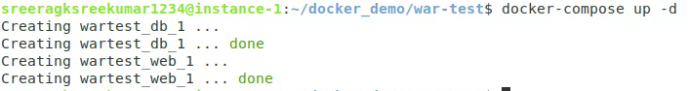

**docker ps –a**



**Output**:

